Power BI Assignment 3

1. List and explain different Power-Bi products?

* Microsoft Power BI is a collection of tools used to import, aggregate and present data in the form of immersive and easy to digest reports and visuals.
* POWER BI DESKTOP – A windows desktop application for data analysis and reports creation.
* POWER BI SERVICE – Online software as a service, used to collaborate and distribute Power BI reports.
* POWER BI MOBILE – A native mobile application used in mobile for report creation.
* POWER BI REPORT BUILDER – A tool for creating paginated reports (all are required data in a table format).
* POWER BI REPORT SERVER – An on-premises report server (available in Power BI premium licence).
* POWER BI EMBEDDED – A service to embed visuals, reports and dashboards into an application.

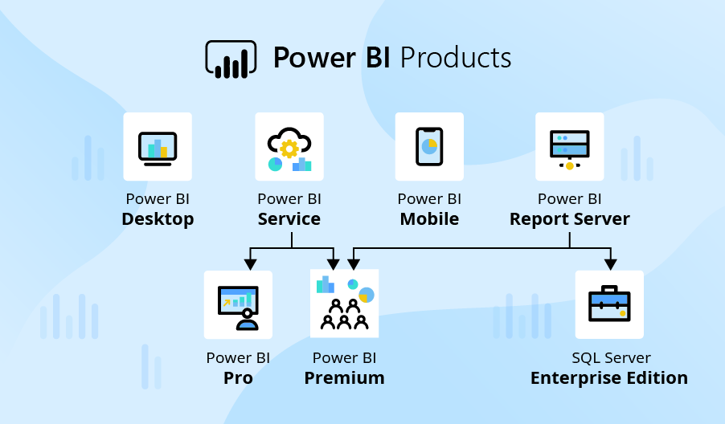

1. **What limitations of Excel, Microsoft solved by PowerBi?**

* Excel has limitations in the amount of data it can work with. In contrast, Power BI can handle much larger amounts of data. Also, Unlike Excel, Power BI can be easily used from mobile devices.
* Power BI is a faster processing than Excel. Also Power BI dashboards are more visually appealing, interactive and customizable than those in Excel.
* Power BI is more users friendly and easy to use than excel.
* Excel doesn’t have advanced cross-filtering between graphics; on the other hand, Power BI supports cross-filtering filters between charts.
* In Excel, data is not automatically update but in Power BI, data is automatically updated.
* Difficult to connect separate table in Excel, but it is easy process to connect separate tables in Power BI with the help of data modelling.
* Excel is used to organize data, transform it and perform mathematical operations and calculations. On the other hand, Power BI is conceived as a business intelligence and data visualization tool for business.

1. **Explain PowerQuery?**

* Power Query is a powerful tool used to connect many different data sources and transform the data into the shape we want.
* Power Query is the data connectivity and data preparation technology that enables end users to seamlessly import and reshape data within wide range of Microsoft products including Excel, Power BI, Analysis services and more.
* Power Query (M) is used to query data sources, clean and load data. Another point, we can say Power Query is a data transformation and data preparation engine. It comes with a graphical interface for getting data from sources and Power Query Editor for applying transformations. Because the engine is available in many products and services, the destination where the data will be stored depends on where Power Query is used.
* Using Power Query, we can perform the extract, transform and load (ETL) processing of data.

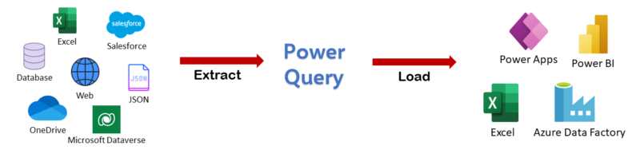

**4. Explain Power Map?**

* Microsoft Power Map is a 3-Dimensional data visualization tool. A power map lets us discover insights us might not see in traditional 2-Dimension tables.
* In Power BI,Power BI Service and Power BI Desktop send Bing the geographical data; it needs to create the map visualization. This may include the data in the location, Latitude, Longitude buckets of the visuals field well.
* With Power Map, we can plot geographic and temporal data on a 3-Dimension globe or custom map, show it over time and create visual. So, we can share it with other people.

1. **How Power BI eliminated the need to host SharePoint Server on premises?**

* Share point is an important part of how many organizations organize and distribute BI content to users. Over the last year, they have introduced Power BI web part for share point online and an updated reporting service report viewer web part for share point on-premises.
* Customers like the flexibility this gives them to build highly-customized share point experiences using their BI content.

1. **Explain the updates done in Power Bi Service(power BI 2.0) as compared to older version?**

* Last updated done on September 2022. This release introduces Power BI report server for SQL server 2022. They continue to innovate, create and design to give everyone the ability to achieve more.
* In this new release of Power BI report server, they have done a lot of work to make sure they are empowering everyone. The release includes,
* Enhanced Windows Narrator support for the new windows Operating System and windows server.
* Security Enhancements.
* Browser performance improvements with angular.
* Accessibility BUG fixes.
* Support for SQL server 2022, preview instances report server catalog and feature updates.
* Improved the Power BI report server portal to provide more inclusive modern graphical interface
* Introduced the new paginated report migration tool, which connects to the web from the Power BI report server.